

Inventory planning module

Documentation

V3.0

Document Released: December 17, 2015

frePPLe bvba  
Woluwestraat 17  
1930 Zaventem  
http://frepple.com

**Table of Contents**

1. Introduction 3

2. User guide 4

a. Distribution planning screen 4

b. Inventory planning parameter report 4

c. Execution screen 6

3. Configuration 7

4. Mathematical background 8

a. Reorder quantity 8

b. Safety stock 9

**The COMPLETE content of this DOCUMENT Is   
under copyright of frePPLE bvba.**

**distRIBUTIOn of this document is not allowed   
without explicit authorization from frePPLe BVBA.**

# Introduction

This document describes the inventory planning module of frePPLe. This module allows the calculation of the optimized reorder quantities and safety stocks for all buffers.

This is an important aspect of your planning process, as safety stocks are required to:

* Safety stocks are required to meet the expected service level of your customers.  
  When customer delivery times are shorter than the production or purchasing lead times, inventories are required to cover the expected demand over the lead time and its variability.
* Safety stocks covers for variability on the supply side.  
  Supplier purchasing lead times and manufacturing times have a level of variability that needs to be planned for to support a smooth progress of all activities.

This module computes these safety stock and reorder quantities, which are then used by the planning algorithm to generate matching replenishment plans.

# User guide

Three screens can be used in the

* Distribution planning screen
* Inventory planning parameter report
* Execution screen

## Distribution planning screen

TODO

## Inventory planning parameter report

This report allows easy mass-maintenance of all inventory planning parameters.

You can directly edit the values in the data grid. Alternatively you can upload them as an excel spreadsheet.

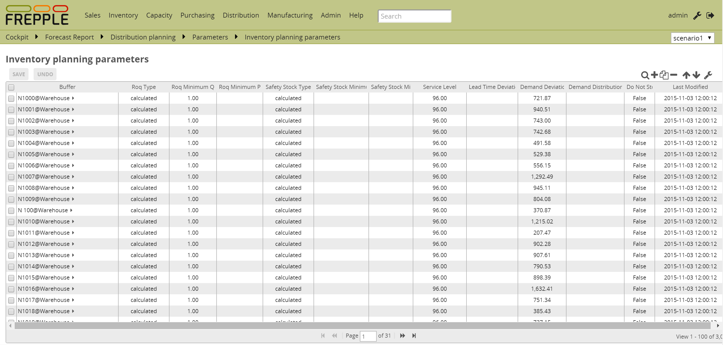

## Execution screen

The execution screen has an extra option in the plan generation task:

* **Generate inventory planning parameters**

This task calculates the reorder points and safety stocks.   
It is common to run different planning cycles.   
For instance:

* + A monthly planning cycle which recomputes the forecast and inventory planning parameters.
  + A daily planning cycle which replans the production plan with the forecast and inventory planning parameters set earlier in the monthly cycle.  
    This avoids unnecessary nervousness in the plans.
* **Evaluate stock position**  
  This task evaluates the performance of each item-location combination and stores the results in the database. This pre-computed evaluation allows good performance for the distribution planning screen, also in big models.  
  This task should be run whenever the plan or inventory data are being updated.

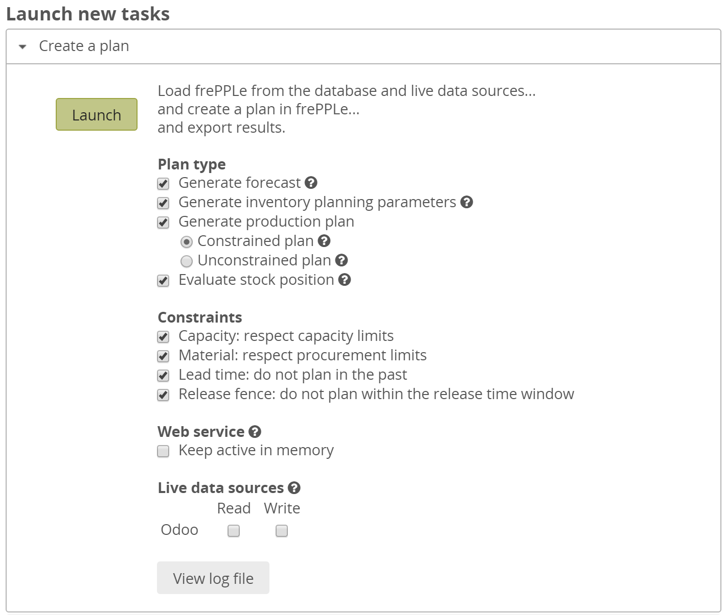

# Configuration

The following extra parameters are introduced by this module.

|  |
| --- |
| **Parameter inventoryplanning.calendar:** Name of a calendar model to define the granularity of the time buckets for inventory planning.  This parameter is mandatory.  The calendar needs to have a specific structure:   * The parameter forecast.calendar needs to have the same value. A mismatch will result in unintuitive planning results. * It needs a calendar bucket for every bucket. * The start and end date of subsequent buckets must match exactly without any time gap in between. |
| **Parameter inventoryplanning.fixed_order_cost:** Holding cost percentage to compute economic reorder quantity.  Default value: 0.05 |
| **Parameter inventoryplanning.holding_cost:** Fixed order cost to compute the economic reorder quantity.  Default value: 20 |
| **Parameter inventoryplanning.horizon_end:** Specifies the number of days in the future for which we generate safety stock and reorder quantity values.  Default: 365 |
| **Parameter inventoryplanning.horizon_start:** Specifies the number of days in the past for which we generate safety stock and reorder quantity values.  Default: 0 |
| **Parameter inventoryplanning.loglevel:** Controls the verbosity of the inventory planning solver.  Accepted values are 0(silent - default), 1 and 2 (verbose) |
| **Parameter inventoryplanning.service_level_on_average_inventory :** Flag whether the service level is computed based on the expected average inventory. When set to false the service level estimation is based only on the safety stock.  Default value: false |

# Mathematical background

## Reorder quantity

The suggested reorder quantity is computed with the classic Wilson formula.

The computed value represent an optimal balance between the cost of carrying inventory in your warehouse and the costs associated with each order. If the order quantity gets larger, the costs of carrying inventory in the warehouse will grow. And if the order quantity gets smaller, the ordering frequency goes up and all costs associated with the handling of an order.

$$Reorder quantity= \sqrt{\frac{2*D*K}{H}}$$

In which:

* D: annual forecast quantity
* K: fixed cost per order, which covers the shipping cost, handling costs and administrative time that are incurred with every order
* H: annual holding cost per unit, also known as carrying cost or storage cost

See <https://en.wikipedia.org/wiki/Economic_order_quantity> for more background.

## Safety stock

The safety stock is computed to reach a specified service level.

The calculation is based on the following elements:

* **Supply lead time of the item**The safety stock is calculated based using the smallest of a) the replenishment lead time and b) the period covered by reorder quantity (ie = reorder quantity / forecasted demand).  
  The second term accounts for item-locations with multiple open replenishments during the replenishment lead time.
* **Average expected forecast over the supply lead time**.  
  This is computed by frePPLe’s forecast module.
* **Standard deviation of the forecast over the supply lead time**.  
  FrePPLe’s forecast module also computes the expected standard deviation between the forecast and the actual demand.  
  The 2 examples below have the same average forecast. The item-locations with the higher volatility obviously will require a higher safety stock to provide the same service level.  
  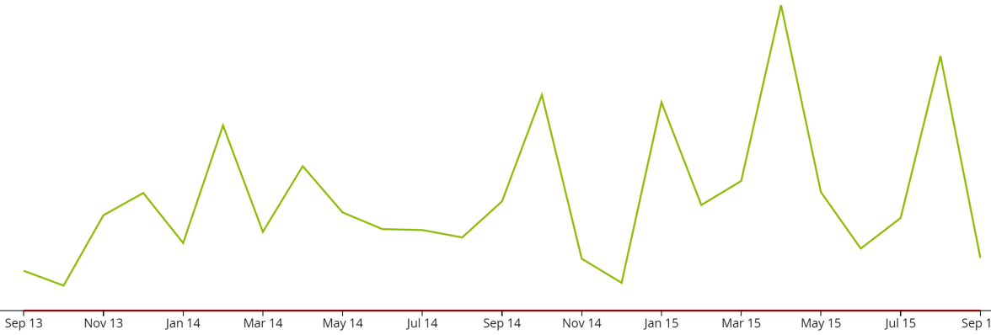

Figure 1 Item-location with a highly volatile demand pattern

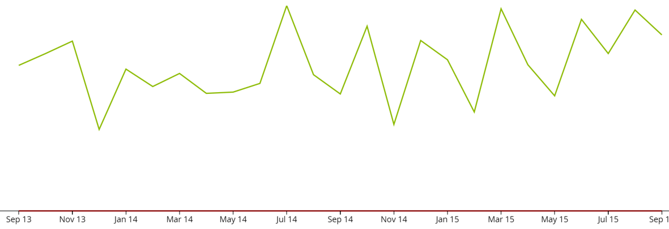

Figure 2 Item-location with a (relatively) stable demand pattern

* **Standard deviation of the lead time**.  
  In the same way as the demand is variable, also the supply lead time can be variable. This also results in a higher safety stock need.  
  This input value is provided as input data to frePPLe.
* **Statistical distribution to be applied on the forecast**  
  Based on the expected total demand over the lead time and its variability, frePPLe will fit a statistical distribution.  
  We will automatically select from:  
  + **Normal / Gaussian distribution**Used for all fast-moving items.  
    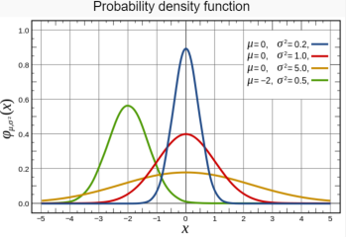  
    *Figure 3Normal distribution*

See <https://en.wikipedia.org/wiki/Normal_distribution>

* + **Poisson distribution**Used for slow movers.  
    This distribution is typical for slow moving spare parts: if the probability of a part failure is constant, the number of failures in a certain period is distributed according to a Poisson distribution.  
    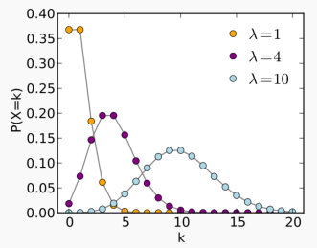  
    *Figure 4Poisson distribution*  
    See <https://en.wikipedia.org/wiki/Poisson_distribution>
  + **Negative binomial**Used for slow movers with a highly variable demand pattern.  
      
    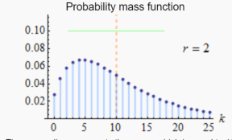  
    *Figure 5Negative binomial distribution*

See <https://en.wikipedia.org/wiki/Negative_binomial_distribution>

Combining all the above we can establish the translation curve between the safety stock and service level.   
Given a desired service level, we can use it to look up the required safety stock level to reach it.  
Given a certain inventory level, we can use it to look up the service level we can expect it to provide.

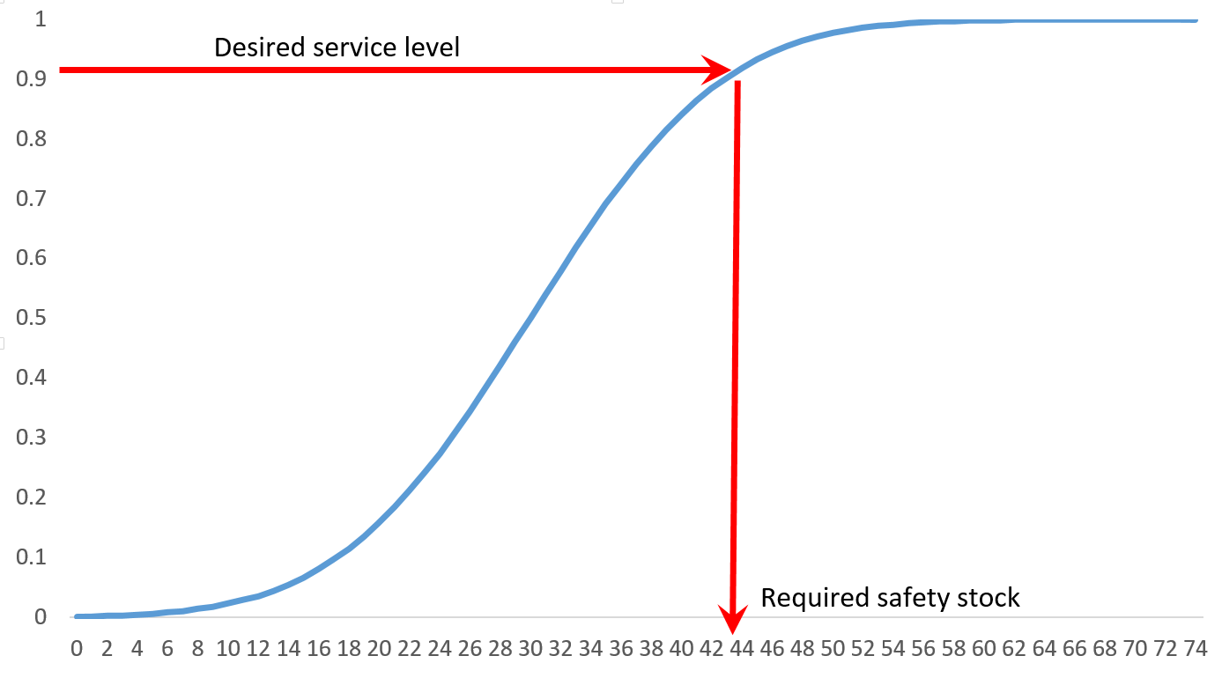

Figure Translating between service level and safety stock

The calculation can be done considering the average inventory (= safety stock + half of the reorder quantity), or considering only the safety stock.   
An example to illustrate the difference:

* Imagine an item for which the reorder quantity represents 1 year of forecasted demand
* If the service level is computed on the average inventory:  
  The service level will be very high, even if the safety stock is 0. Because of the high reorder quantity, we’ll have less than 1 stockout per year.  
  The service level represents the total service we plan for towards customers.
* If the service level is computed on the safety stock only (default setting):  
  The safety stock level will be higher and be more realistic to actually avoid stockouts.   
  The service level should be interpreted as a stockout probability in this case, as we only consider only the lowest stock level.   
  The service level towards customers will be higher.

The correct interpretation is important when specifying the service level in frePPLe.